457.557 Water Resources Systems Engineering, Spring 2022
Tue 17:00 PM – 19:50 PM, Building 35 Room 514

INSTRUCTOR Prof. Young-Oh Kim
CO-INSTRUCTOR Dr. Gi Joo Kim
OFFICE/TELEPHONE Building 35 Room 205, (+82) 02-880-8354
EMAIL gjk_0494@snu.ac.kr
OFFICE HOURS Email for appointment (generally Tuesday mornings best)

PRIMARY TEXTBOOK
- Loucks, D. P. & Van Beek, E. (2017). Water Resource Systems Planning and Management: An Introduction to Methods, Models, and Applications. Springer.
(Available freely at the following link: https://ecommons.cornell.edu/handle/1813/48159)
LOOK FOR THE 2017 EDITION, NOT 2005 EDITION
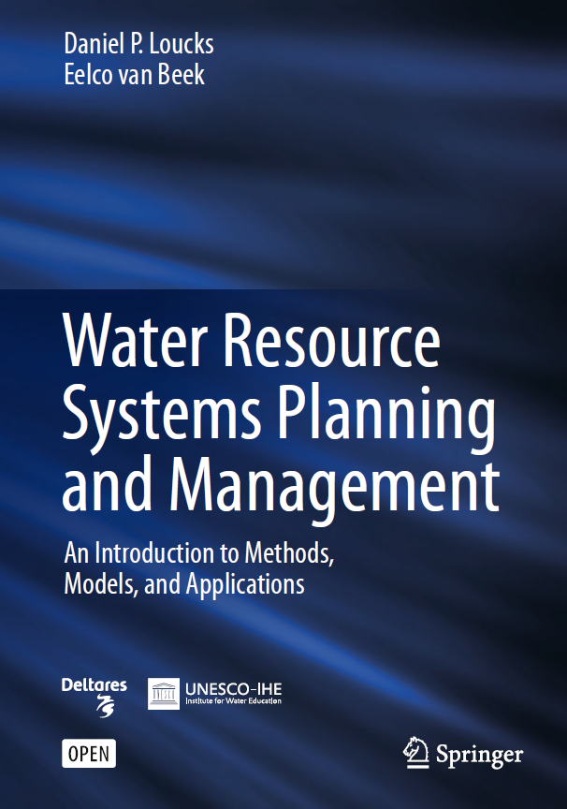

SUGGESTED FURTHER READINGS
- Mays, L. W. & Tung, Y.-K. (1992). Hydrosystems Engineering and Management. Water Resources Publications, LLC.
- Loucks, D. P., Stedinger, J. R., & Haith, D. A. (1981). Water Resource Systems Planning and Analysis. Prentice-Hall.
- Lee, K. S. (2000). Fundamentals of Water Resource Systems. SaeRon Publishing Co.
- Soncini-Sessa, R., Weber, E., & Castelletti, A. (2007). Integrated and Participatory Water Resources Management-Theory. Elsevier.

COURSE DESCRIPTION
Given the stress from various factors affecting water resources systems, such as hydroclimatic variabilities and uncertain demands, planning and managing of the systems is extremely challenging. This course includes general introduction to the current challenges in the field of water resources systems engineering, both traditional and novel optimization algorithms commonly utilized for analysis, and also frontier challenges in the same field. The final project will both encourage and challenge students to confront the real-world challenge of water resources engineering problems with their problem-solving skills acquired during the course.

PREREQUISITS
- Basic statistics
- Coding in either of the following computer languages: R, Matlab or Python
- Credits can be given to students completing additional coding exercise throughout the semester (consult for more details)

TOPICS COVERED
- Water resources systems modeling
- Mathematical programming models including LP, NLP, DP & evolutionary optimizations
- Probability, statistics, uncertainty analysis
- Simulation-based problem solving

GRADING
Participation 10%
Assignments 25%:
(English for PhD Course Students, Either English/Korean for MS Course Students)
Quizzes 25%
Test 25%
Final Project 15%
- 위의 명시되지 않은 부분에 있어서는 서울대학교 학칙 및 규정에 따름.
- 늦게 제출되는 과제/프로젝트의 경우에는
제출기한 이후 3일까지 하루에 -10% (최대 -30%), 4-7일까지 -50%, 7일 초과시 0%.
COURSE SCHEDULE (SPRING 2022)
WEEK/DATE | TOPIC | ASSIGNMENTS  QUIZ
1  Mar-07 (M) | Course Introduction  Lec 01: Introduction to Water Resources Systems Engineering
2  Mar-15 | Lec 02: Water Resources Systems Modeling  Training with Systems Modeling (LT)
3  Mar-22 | Lec 03: Introduction to Conventional Optimization Models (DP & LP) Part I | Assignment 1 Due
4  Mar-29 | Lec 04: Introduction to Conventional Optimization Models (DP & LP) Part II | Quiz 1
5  Apr-05 | Training with Conventional Optimization Models (LT)  Final Project Introduction
6  Apr-12 | Lec 05: Data-fitting, Evolutionary Optimization Models | Assignment 2 Due
7  Apr-19 | Training with Evolutionary Optimization Models (LT)
8  Apr-26 | Field Trip (Details TBD)
9  May-03 | Lec 06 Probability, Statistics, Uncertainty, and  Stochastic Simulations Part I | Quiz 2
10  May-10 | Lec 07: Probability, Statistics, Uncertainty, and  Stochastic Simulations Part II | Assignment 3 Due
11  May-17 | TEST (Closed Book)
12  May-24 | Training with Stochastic Simulations (LT)  Lec 08: Performance Criteria
13  May-31 | Lec 09: Water Resources Systems Engineering Frontiers- Introduction and Examples Part I | Quiz 3
14  Jun-07 | Lec 10: Water Resources Systems Engineering Frontiers- Introduction and Examples Part II (Invited Talk) | Assignment 4 Due
15  Jun-14 | Final Project Presentation  Grading Check | Final Project Report Due

